PYTHON PROGRAMMING
CASE STUDY ASSIGNMENT – 4

Case Study 4: Attendance Recovery Computation.
1. Problem Statement
Attendance is an important requirement for students in colleges. Students who have low attendance need to know how many additional classes they must attend to reach the required attendance percentage. Calculating this manually can be time-consuming and confusing. This project develops a Python program that calculates the student's current attendance percentage and determines the minimum number of consecutive classes the student must attend to achieve the required attendance percentage.

2. Objectives
- To calculate the student's current attendance percentage.
- To check whether the student meets the required attendance percentage.
- To determine the minimum number of additional consecutive classes the student must attend to reach the required percentage.
- To validate the attendance details entered by the user.
- To display the attendance percentage and the number of additional classes required.

3. Assumptions
- The total number of classes conducted must be greater than zero.
- The number of classes attended cannot be negative or greater than the total classes conducted.
- The required attendance percentage must be between 1% and 100%.
- The student attends every additional class without missing any.
- Each additional class increases both the number of classes attended and the total number of classes conducted by one.
- The program calculates the minimum number of additional consecutive classes needed to reach the required attendance percentage.

4. Algorithm
- Start the program.
- Input the total number of classes conducted.
- Input the number of classes attended by the student.
- Input the required attendance percentage.
- Check whether the entered values are valid.
- Calculate the current attendance percentage using the formula:
Attendance Percentage = (Classes Attended / Total Classes Conducted) × 100
- If the current attendance percentage is greater than or equal to the required percentage, display that the requirement is already achieved.
- Otherwise, initialize the number of additional classes to zero.
- Increase the number of additional classes until the attendance percentage reaches the required percentage, assuming the student attends every new class.
- Display the current attendance percentage and the minimum number of additional classes required.
- Stop the program.

5. Flowchart
Input total classes, attended classes, and required percentage
START
6. Pseudocode
STOP
Display "Invalid input"
Display attendance and additional classes needed
If yes: display 0 additional classes; otherwise, count classes until the target is reached
Attendance ≥ required percentage?
Calculate current attendance percentage
IF NO
IF YES
Are the inputs valid?
START
INPUT total _classes
INPUT attended_ classes
INPUT required _percentage
IF total_ classes <= 0 OR attende _classes < 0 OR attended_ classes > total_ classes THEN
DISPLAY "Invalid attendance details"
ELSE IF required _ percentage <= 0 OR required _ percentage > 100 THEN
DISPLAY "Invalid required percentage"
ELSE
Current _percentage = (attended_ classes / total _classes) * 100

DISPLAY current _ percentage

IF current_ percentage >= required _ percentage THEN

Additional _ classes = 0

DISPLAY "Required attendance already achieved"

ELSE

Additional _classes = 0

WHILE ((attended _ classes + additional_ classes) / (total_ classes + additional _ classes)) * 100 < required _ percentage

Additional _classes = additional_ classes + 1

END WHILE

DISPLAY additional _classes

END IF
END IF
STOP
7.Source Code
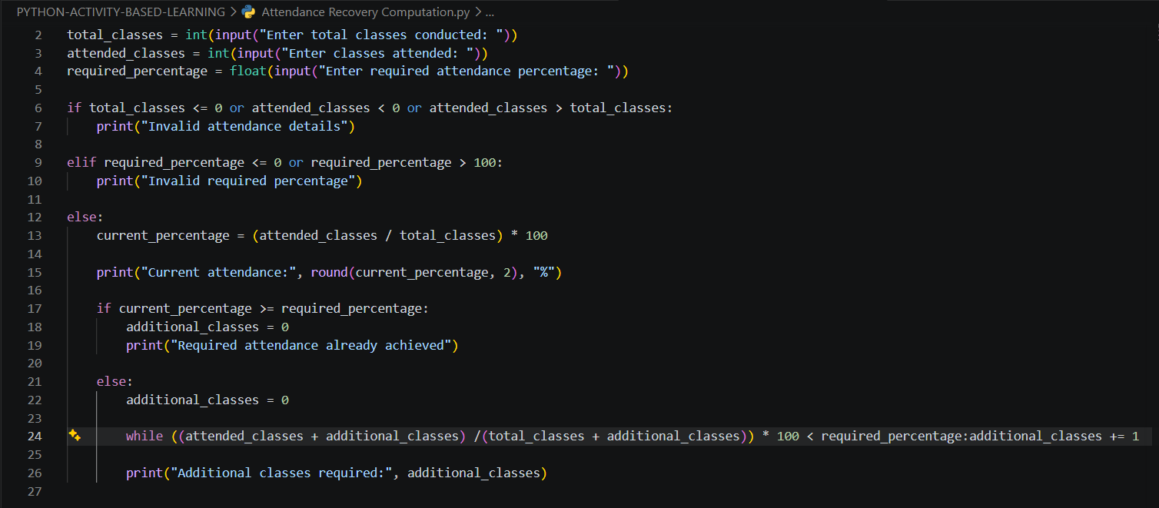
8. Test Cases
Test Case | Input | Expected Output
TC1 | Total classes = 100, Attended = 70, Required = 75% | Current attendance = 70%; Additional classes required = 20
TC2 | Total classes = 80, Attended = 64, Required = 75% | Current attendance = 80%; Required attendance already achieved; Additional classes = 0
TC3 | Total classes = 50, Attended = 30, Required = 80% | Current attendance = 60%; Additional classes required = 50
TC4 | Total classes = 0, Attended = 0, Required = 75% | Invalid attendance details
TC5 | Total classes = 100, Attended = 70, Required = 105% | Invalid required percentage

9. Output Screenshots
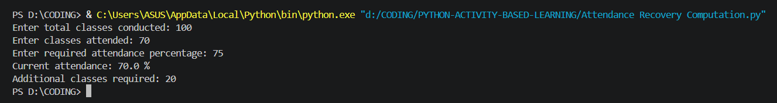

10. Conclusion
The Attendance Recovery Computation program calculates a student's current attendance percentage and determines the minimum number of additional consecutive classes required to reach the target attendance percentage. It validates user inputs and uses conditional statements, loops, and arithmetic operations to perform the calculations. This project demonstrates how Python can be used to solve a practical problem faced by students.

